Guide and Prices for Classic Frames

- Prices for classic frames are highly variable – please either contact me directly via my contact details page at http://www.chasingrays.co.uk/wpsite/contact/ or send a completed order form below for a no obligation initial quote.

- Delivery:
    - All bespoke products require some time to be produced - please allow up to four weeks (20 working days) for delivery of your product from the time you upload/ send your digital image or otherwise from the time of your portrait session.
Postage and packing costs are calculated by the total weight of your order; this is calculated in real time through Royal Mail, so the total cost will not be available until you have begun to put items in your basket.

- General requirements for classic frame products:
    - You will need to supply one image with each product ordered.
    - I am happy to arrange a portrait session to provide you with an image for your small accessories – please contact me as per the details at the head of this page or use my contact details page at http://www.chasingrays.co.uk/wpsite/contact/. For more details on portrait sessions see my website page at:
http://www.chasingrays.co.uk/wpsite/services-and-products/photography-sessions/portrait-sessions/.
    - If you wish to supply your own digital image(s), you may arrange for the creation of an upload account, either by contacting directly as per the details in 2(ii), or through my account request form at http://www.chasingrays.co.uk/wpsite/client-area/download-accounts/. Otherwise, please feel free to supply your own image on CD/ DVD – in each case, please include contact details, a completed copy of the order form at the end of this guide and any further information you may feel necessary with your CD/ DVD.

- Image quality:
    - Out of preference, all images supplied to me should be in JPEG format using either an sRGB or AdobeRGB colourspace at 300 dpi as a minimum requirement.
    - If your images are not in JPEG format, I can accept a number of image formats – please contact me as in section 3(ii) with any queries regarding image format and quality, or to send me an example image for testing.

- Conditions of use of upload and download accounts apply:
    - Accounts will be monitored for inappropriate material. Whilst it remains a last resort, any users found uploading or sharing inappropriate material will have their accounts suspended and any offending materials will be deleted.
    - In agreeing to use this upload and download facility, you acknowledge that Chasing Rays Photography cannot be held responsible for the quality of the internet connection to our server. These can vary depending on time of day and week, with peak usage often occurring around 6 pm. If you experience repeated problems, please contact me as detailed in 1(i) or 1(ii) to make alternative arrangements for delivery of your files.
    - A fair usage policy (15 files total, 20 Mb per file, 300 Mb total upload for each upload session) applies. If you wish, you may use multiple sessions to upload multiple files.

- Further details on upload and download accounts:
    - See the documentation at http://www.chasingrays.co.uk/wpsite/client-area/ and http://www.chasingrays.co.uk/wpsite/price-lists-and-guides/.

- Guide to ordering your frame (see ordering form below for more details):
    - Choose a frame size, in inches or millimetres. If you require a print, I am able to print up images up to A3+ (13” x 19”) by default; images with a larger short edge will require outsourcing which may incur additional cost (an such costs will be itemised on your initial quote).
    - Choose your frame style; see the two tables below as a guide to your choice:

Black 01 | Black 02 | Black 03 | Black 04
 |  | 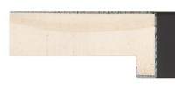
Black 05 | Black 06 | Black 07 | Black 08
 |  | 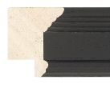
Black 09 | Black 10 | Black 11 | Black 12
 | 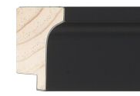
Black 13 | Black 14 | Black 15 | Black 16
 |  |  | 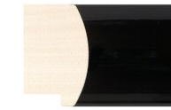
Black 17 | Black 18 | Black 19 | Black 20
 | 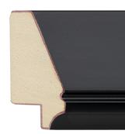 | 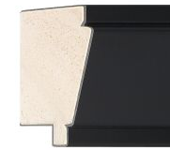 | 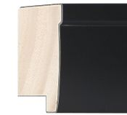
Black 21 | Black 22 | Black 23 | Black 24
 | 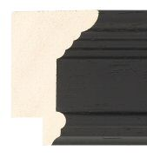 | 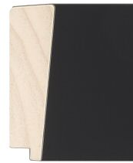 | 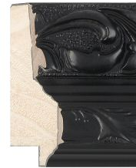
Black 25 | Black 26 | Black 27 | Black 28
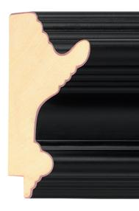 | 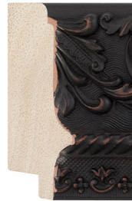 | 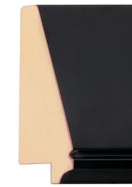 | 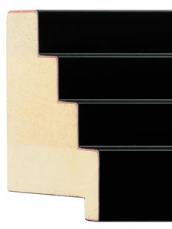
Black 29 | Black 30 | Black 31 | Black 32
 |  |  | 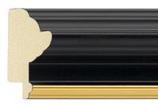
Black-gold 01 | Black-gold 02 | Black-gold 03 | Black-gold 04
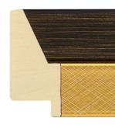 |  | 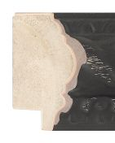
Black-gold 05 | Black-gold 06 | Black-gold 07 | Black-gold 08
 |  |  | 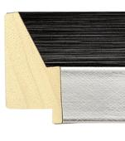
Black-silver 01 | Black-silver 02 | Black-silver 03 | Black-silver 04
 | 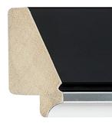 |  | 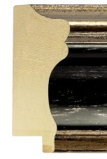
Black-silver 05 | Black-silver 06 | Black-silver 07 | Black-silver 08
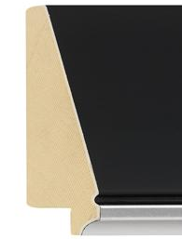
Black-silver 09
Bronze 01 | Bronze 02 | Bronze 03 | Bronze 04
 | 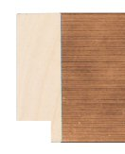
Bronze 05 | Bronze 06 | Bronze 07 | Bronze 08
Brown 01 | Brown 02 | Brown 03 | Brown 04
 | 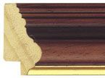 | 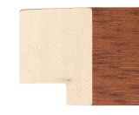 | 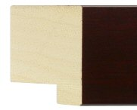
Brown 05 | Brown 06 | Brown 07 | Brown 08
 | 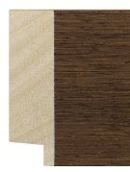 | 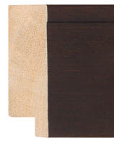 | 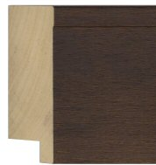
Brown 09 | Brown 10 | Brown 11 | Brown 12
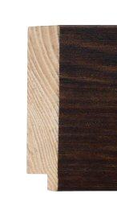 | 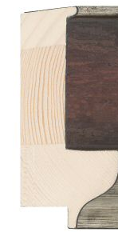
Brown 13 | Brown 14 | Brown 15
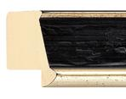 | 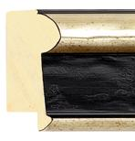 | 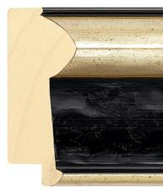
Ebony-silver 01 | Ebony-silver 02 | Ebony-silver 03
 |  | 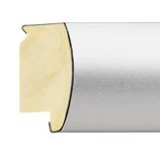 | 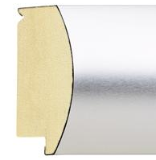
Metal 01 | Metal 02 | Metal 03 | Metal 04
 |  |  | 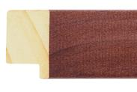
Natural wood 01 | Natural wood 02 | Natural wood 03 | Natural wood 04
 | 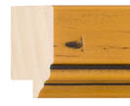
Natural wood 05 | Natural wood 06 | Natural wood 07 | Natural wood 08
Natural wood 09 | Natural wood 10 | Natural wood 11 | Natural wood 12
Natural wood 13 | Natural wood 14 | Natural wood 15 | Natural wood 16
 | 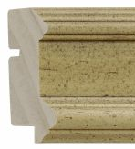 | 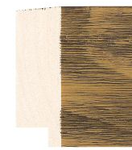 | 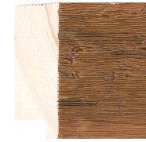
Natural wood 17 | Natural wood 18 | Natural wood 19 | Natural wood 20

Frame ID | Profile | Material | Finish | Size / mm | Rebate / mm
Black 01 | Flat | Meranti | Paint | 20 | 7
Black 02 | Cushion | Jelutung | Stain | 20 | 7
Black 03 | Flat | Ayous | Stain | 21 | 27
Black 04 | Flat | Ayous | Stain | 22 | 47
Black 05 | Flat | Radiata pine | Paint | 23 | 13
Black 06 | Flat | Ayous | Brushed | 23 | 8
Black 07 | Flat box | Radiata pine | Paint | 25 | 50
Black 08 | Flat | Meranti | Paint | 30 | 7
Black 09 | Flat | Ayous | Foil | 30 | 10
Black 10 | Flat | Meranti | Paint | 30 | 7
Black 11 | Scoop | Ayous | Paint | 30 | 12
Black 12 | Flat | Radiata pine | Paint | 30 | 20
Black 13 | Cushion | Ayous | Stain | 31 | 10
Black 14 | Scoop | Radiata pine | Paint | 33 | 9
Black 15 | Scoop | Ayous | Paint | 33 | 6
Black 16 | Bevel | Radiata pine | Paint | 35 | 9
Black 17 | Flat | Ayous | Paint | 37 | 19
Black 18 | Flat | Meranti | Paint | 38 | 7
Black 19 | Cushioned Bevel | Ayous | Brushed paint | 39 | 11
Black 20 | Flat | Ayous | Laquer | 39 | 15
Black 21 | Flat | Ayous | Stain | 43 | 9
Black 22 | Reverse | Pine | Paint | 50 | 14
Black 23 | Bevel | Pine | Paint | 50 | 12
Black 24 | Cushion | Radiata | Paint | 50 | 13
Black 25 | Flat | Plastic | Brushed foil | 50 | 10
Black 26 | Spoon | Ayous | Paint | 52 | 14
Black 27 | Bevel | Radiata pine | Paint | 68 | 9
Black 28 | Reverse | Pine | Paint | 75 | 12
Black 29 | Spoon | Pine | Paint | 80 | 8
Black 30 | Reverse | Radiata pine | Paint | 85 | 16
Black 31 | Reverse | Poplar | Paint | 85 | 16
Black 32 | Reverse | Pine | Paint | 91 | 40
Black-gold 01 | Flat | Ramin | Paint | 18 | 8
Black-gold 02 | Reverse | Ayous | Stain | 33 | 9
Black-gold 03 | Flat | Pine & spruce | Paint & foil | 35 | 12
Black-gold 04 | Spoon | Ayous | Paint | 35 | 5
Black-gold 05 | Reverse | Ayous | Foil & spray | 45 | 20
Black-gold 06 | Flat | Jelutung | Paint | 46 | 7
Black-gold 07 | Dome | Meranti | Paint | 48 | 12
Black-gold 08 | Reverse | Pine | Paint | 49 | 13
Black-silver 01 | Flat | Pine & spruce | Paint & foil | 35 | 12
Black-silver 02 | Flat | Ayous | Laquer | 40 | 27
Black-silver 03 | Flat | Jelutung | Paint | 44 | 11
Black-silver 04 | Reverse | Ayous | Foil & spray | 45 | 20
Black-silver 05 | Flat | Jelutung | Paint | 46 | 7
Black-silver 06 | Reverse | Pine | Paint | 49 | 13
Black-silver 07 | Bevel | Radiata pine | Paint & foil | 50 | 12
Black-silver 08 | Spoon | Jelutung | Paint & foil | 72 | 15
Black-silver 09 | Reverse | Pine | Paint | 85 | 16
Bronze 01 | Flat | Ayous | Brushed | 23 | 9
Bronze 02 | Spoon | Ayous | Foil | 30 | 11
Bronze 03 | Flat | Poplar | Foil | 33 | 12
Bronze 04 | Flat | Pine & spruce | Brushed | 35 | 12
Bronze 05 | Cushion | Ayous | Brushed | 39 | 11
Bronze 06 | Flat | Ayous | Foil | 45 | 15
Bronze 07 | Flat | Pine | Foil | 61 | 13
Bronze 08 | Flat | Ayous | Brushed | 70 | 18
Brown 01 | Spoon | Ayous | Stain | 24 | 8
Brown 02 | Cushion | Ayous | Stain | 30 | 10
Brown 03 | Bevel | Ayous | Stain | 30 | 9
Brown 04 | Flat | Ayous | Stain | 33 | 9
Brown 05 | Flat | Ayous | Stain | 34 | 10
Brown 06 | Reverse | Ayous | Stain | 35 | 8
Brown 07 | Flat | Ayous | Stain | 39 | 19
Brown 08 | Flat | Ayous | Stain | 39 | 19
Brown 09 | Flat | Ayous | Foil | 39 | 14
Brown 10 | Flat | Ayous | Stain | 53 | 14
Brown 11 | Flat | Marupa | Stain | 60 | 14
Brown 12 | Flat | Jelutung | Stain | 60 | 14
Brown 13 | Flat | Pine | Stain | 69 | 10
Brown 14 | Reverse | Pine | Foil & paint | 93 | 20
Brown 15 | Flat | Meranti | Stain | 108 | 20
Ebony-silver 01 | Reverse | Ayous | Foil & spray | 30 | 17
Ebony-silver 02 | Spoon | Ayous | Foil & spray | 45 | 13
Ebony-silver 03 | Spoon | Ayous | Foil & spray | 70 | 15
Metal 01 | Cushion | Ayous | Brushed | 32 | 7
Metal 02 | Cushion | Ayous | Aluminium wrap | 37 | 10
Metal 03 | Flat | Ayous | Aluminium wrap | 53 | 22
Metal 04 | Cushion | Ayous | Aluminium wrap | 62 | 12
Natural wood 01 | Flat | Ayous | Stain | 20 | 18
Natural wood 02 | Flat | Oak | Bare | 23 | 16
Natural wood 03 | Flat | Oak | Bare | 27 | 10
Natural wood 04 | Flat | Pine | Stain | 30 | 16
Natural wood 05 | Flat | Radiata pine | Stain | 32 | 10
Natural wood 06 | Flat | Radiata pine | Stain | 33 | 11
Natural wood 07 | Flat | Tulip | Bare | 34 | 15
Natural wood 08 | Flat | Oak | Bare | 34 | 14
Natural wood 09 | Flat bevel | Obeche | Bare | 35 | 16
Natural wood 10 | Cushion | Pine | Bare | 38 | 10
Natural wood 11 | Reverse | Ash | Bare | 38 | 13
Natural wood 12 | Stepped | Pine | Bare | 40 | 10
Natural wood 13 | Reverse | Radiata pine | Stain | 42 | 10
Natural wood 14 | Reverse | Radiata pine | Stain | 42 | 10
Natural wood 15 | Flat | Pine | Stain | 42 | 16
Natural wood 16 | Flat | Pine | Stain | 47 | 15
Natural wood 17 | Flat | Radiata pine | Stain | 54 | 10
Natural wood 18 | Reverse | Radiata pine | Stain | 54 | 10
Natural wood 19 | Flat | Pine | Stain | 58 | 14
Natural wood 20 | Flat | Pine | Stain | 58 | 14

    - Choose whether you have two, one or no card mounts around your picture, and border size(s) as appropriate:

Number of Mounts | Example Picture
No mounts | 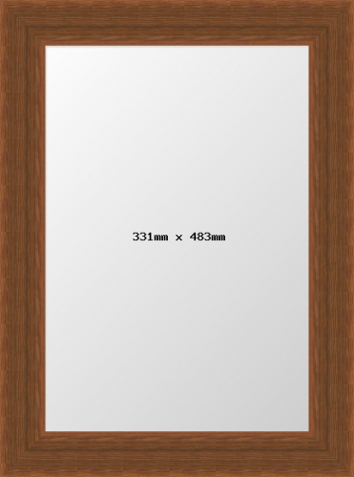
Single mount (top mount only)
Double mount (top and bottom mount) | 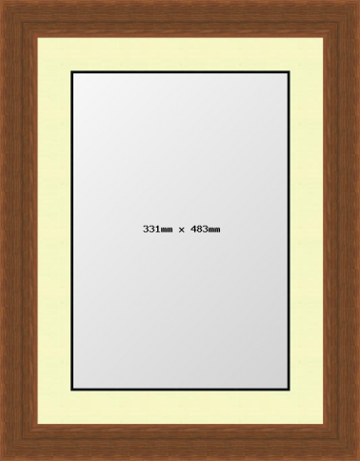

    - Choose the colour(s) of [each of] your mount(s) from the swatches below:
 | Dove |  | Football Red |  | Deep Pink
 | Rust |  | Terracotta |  | Maroon
 | Bamboo |  | Smoke |  | Royal Blue
 | Ocean Blue |  | Damson |  | Damascus Green
 | Silver |  | Snow White |  | Vanilla
 | Snow White (black core) |  | Daffodil |  | Mushroom
 | Malt |  | Silver Grey |  | Moussaka
 | Black |  | Dark Grey |  | Terrazzo Grey
 | Mid Blue |  | Newbury Moss |  | Lakeland Green
 | Mid Green |  | Gold Foil |  | Elise Green
 | Hayseed |  | Alabaster

    - Choose your glazing options.
    - Choose any required extras.
    - I will send an initial quote and example picture(s) of your frame for your consideration; please do not hesitate to contact me as per the details in section 2 or at the head of this page if you have any queries.

Order Form - Classic Frames (up to five)
- CONTACT DETAILS:
Name: _________________________________ TEL: ___________________________
Address: _________________________________ MOB: ___________________________
_________________________________ EMAIL: ___________________________
_________________________________ ___________________________
_________________________________
_________________________________
_________________________________

- IMAGE DETAILS (one image name per classic frame required – see guide for order):
Name of image 1: __________________________________________________
Name of image 2: __________________________________________________
Name of image 3: __________________________________________________
Name of image 4: __________________________________________________
Name of image 5: __________________________________________________
Method by which images to be sent (delete as appropriate): UPLOAD / EMAIL / CD OR DVD BY MAIL

- FRAME STYLE (one style type per classic frame required – see guide for order):
Style of frame 1: __________________________________________________
Style of frame 2: __________________________________________________
Style of frame 3: __________________________________________________
Style of frame 4: __________________________________________________
Style of frame 5: __________________________________________________

- FRAME SIZE REQUIRED (subject to the availability described in section 7 of the guide):
Frame 1: Long edge: ______ inches or ______ mm Short edge: ______ inches or ______ mm
Frame 2: Long edge: ______ inches or ______ mm Short edge: ______ inches or ______ mm
Frame 3: Long edge: ______ inches or ______ mm Short edge: ______ inches or ______ mm
Frame 4: Long edge: ______ inches or ______ mm Short edge: ______ inches or ______ mm
Frame 5: Long edge: ______ inches or ______ mm Short edge: ______ inches or ______ mm

- NUMBER OF MOUNTS REQUIRED (enter 0, 1 or 2 for no mounts, a single mount or a double mount respectively):
For frame 1: Number required: ______ For frame 2: Number required: ______
For frame 3: Number required: ______ For frame 4: Number required: ______
For frame 5: Number required: ______

- MOUNT COLOURS REQUIRED:
For frame 1: Top mount colour: _________________ Bottom mount colour: _________________
For frame 2: Top mount colour: _________________ Bottom mount colour: _________________
For frame 3: Top mount colour: _________________ Bottom mount colour: _________________
For frame 4: Top mount colour: _________________ Bottom mount colour: _________________
For frame 5: Top mount colour: _________________ Bottom mount colour: _________________

- GLAZING OPTIONS AND EXTRAS REQUIRED:
Each of these options will attract a small additional fee (£1.80 per item); please choose one option only for the glazing of your frames. Please enter the number of each required in the boxes below if ordering multiple frames:

GLAZING OPTIONS (choose one only) |  | EXTRAS
Acrylic safety |  | Wall hanging kit
Non-reflective acrylic |  | Foam bumpers
No glazing |  | Small photo frame stand
Super clear premium package |  | Large photo frame stand
Non-reflective premium package |  | Heavy duty hanger (2 pack)
 |  | Heavy duty wall hook (2 pack)
 |  | Security fixings (2 pack)

